Final Report
By: Cooper Wang
Team: Formula SAE
Sub-team: Outboard Structures
Sub-team Leader: Andre Chen
Project Leads: Derrick Sun, Matheus Bellizia
Over the past semester, I worked on numerous projects inside the outboard structures subteam and helped with the overall assembly of the vehicle. Specifically, I helped with the manufacturing of A-arms and the compliance jig, assisted in the cost report, and worked on assembling and disassembling the hubs.
For the A-arms, we manufactured the first batch by using conventional bonding methods for the later compliance testing. The bonding process has been updated from last semester’s testing, which theoretically should guarantee bond quality. However, the etching process produced a greasy surface and a darker surface color than expected, which we suspected would have impacts on the strength of the bond. One of the updates I made to the bond process to further improve precision to cover the Sodium Hydroxide solution before the etching process, which reduces changes in the concentration due to moisture absorption.
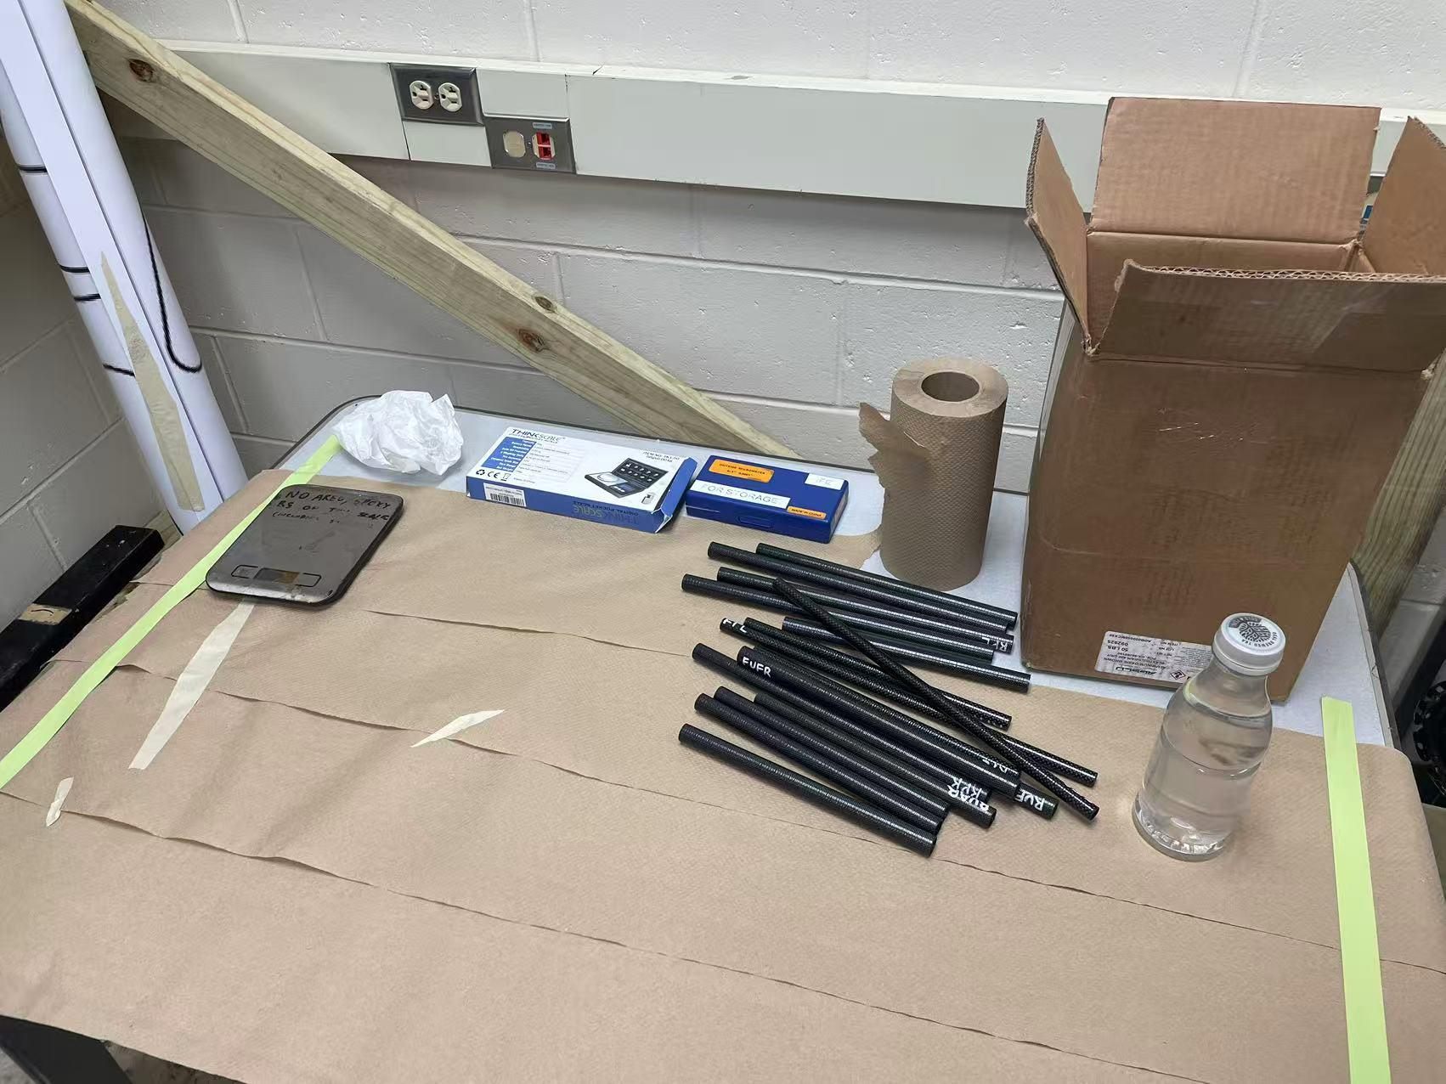
Figure 1. Bonding Setup
In the testing phase, we tested the rods under both compression and tension up to their expected loads, and recorded the resulting data. However, we noticed that for some of the rods, the bonds failed and bubbles are visibly present in the hardened epoxy, which suggests that some part of the bonding process introduced bubbles into the epoxy and affected the strength of the joint. Another problem that we ran into is data that does not match theoretical expectations, such as the fact that one of the bonds seemed to fail first before regaining strength in later testing. As a result, more investigations would be needed in the future to determine accurately the mechanism behind these phenomena.
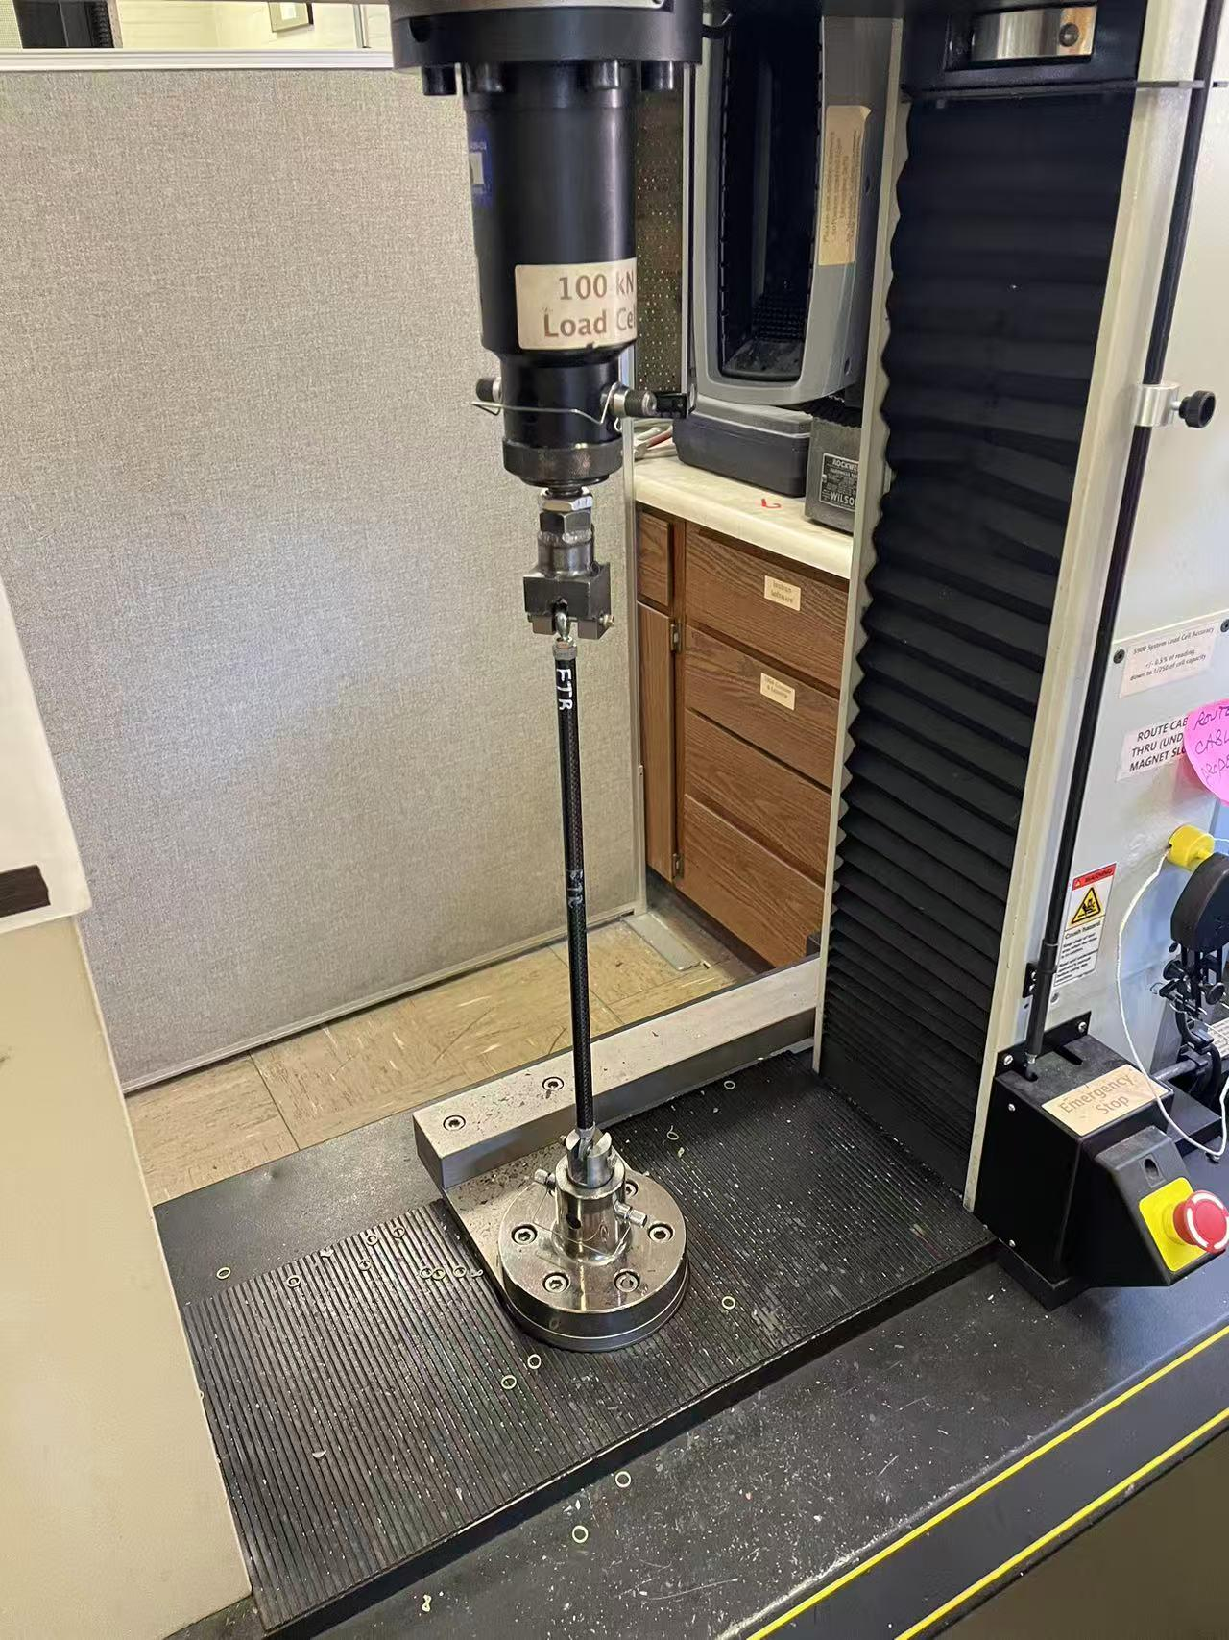
Figure 2. Compliance Testing Setup
At the same time, since the manufacturer of the inserts used 6061 aluminum instead of 7075, which does not meet our requirements, we had to modify the designs for the A-arms and take a different approach to assemble them for the rolling car deadline. Instead of bonding inserts, we opted for welding them directly into metal tubes to act as temporary A-arms. In order to achieve this, we cut out grooves in the tubes that matched the inclination angles on the design, and tried sliding inserts directly into the grooves. However, the inserts did not fit initially, and I ended up cutting the bottom of the inserts off so that they can be welded directly into the tubes.
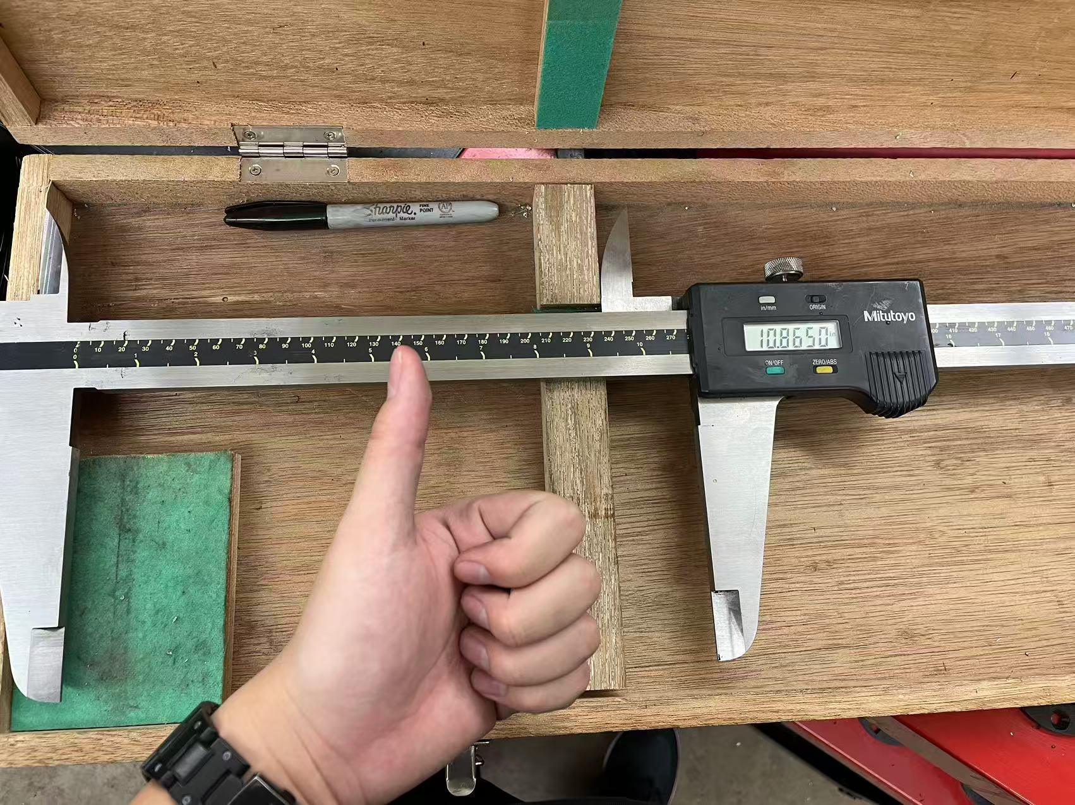
Figure 3. Large Caliper Used for Tube Length Measurement
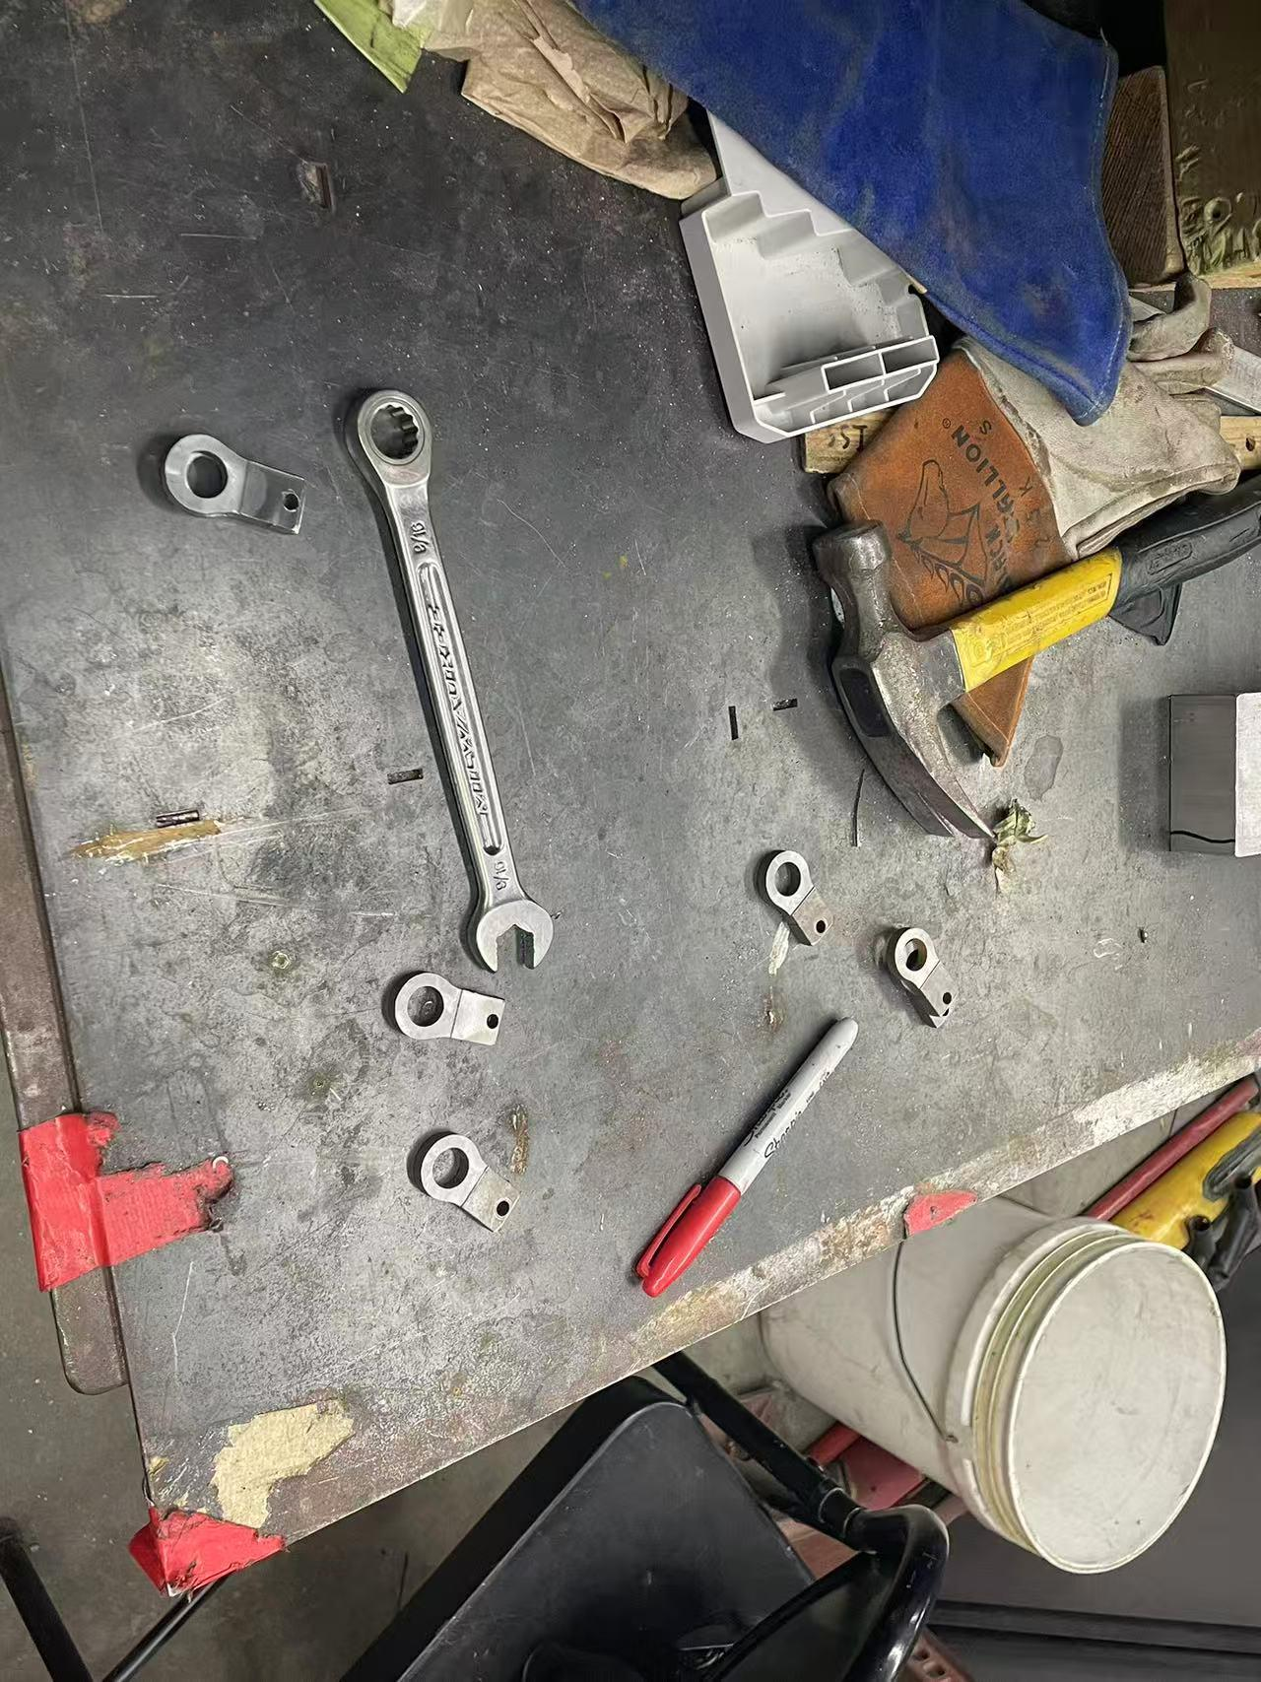
Figure 4. Inserts After Cutting Operation
Another important equipment of the subteam is the compliance jig, which is used to physically measure the compliance of the A-arms. In order to manufacture the jig, we drilled out the holes for the bolts and assembled the individual components based on the CAD design. One of the main challenges was that the alignment of the base beams seems to be off compared to the baseplate, and we had to retry the assembly multiple times in order to correctly put the jig in place.
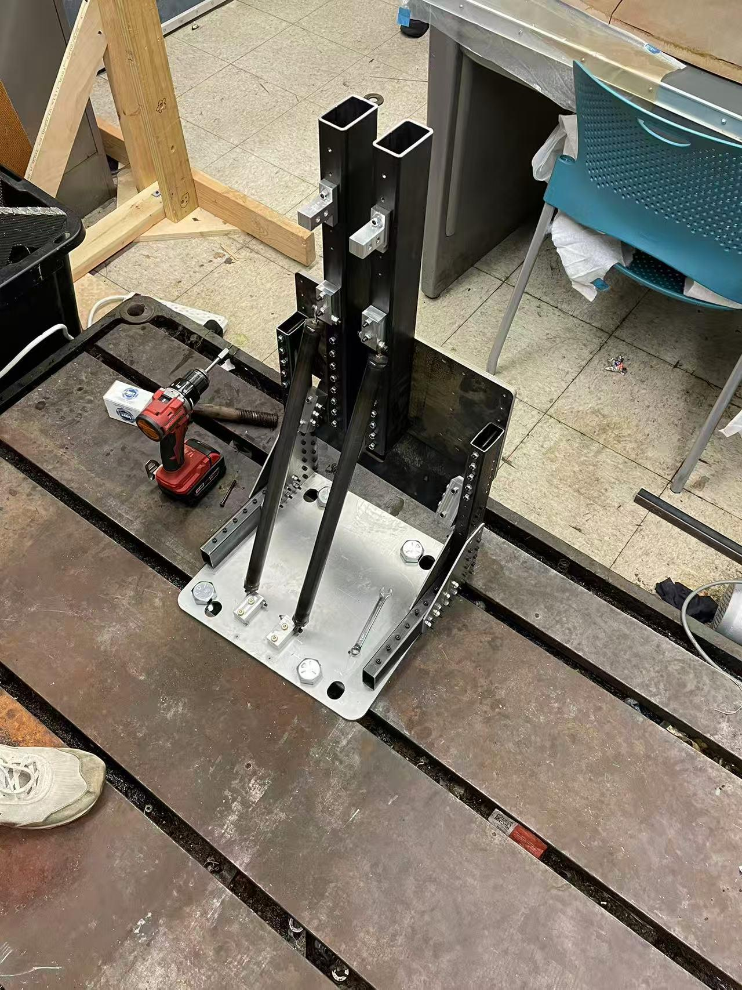
Figure 5. Completed Compliance Jig Assembly
Some other miscellaneous things I did for the suspension subsystem include finding replacement for the hydraulic press, which seems to be inaccurate at the time, and helping to fix the sandblaster, where the nozzle was broken and had to be replaced. I also helped with the cost report of the suspension subsystem, which involved looking at CAD to size the amount of material used and making engineering drawings for the parts.

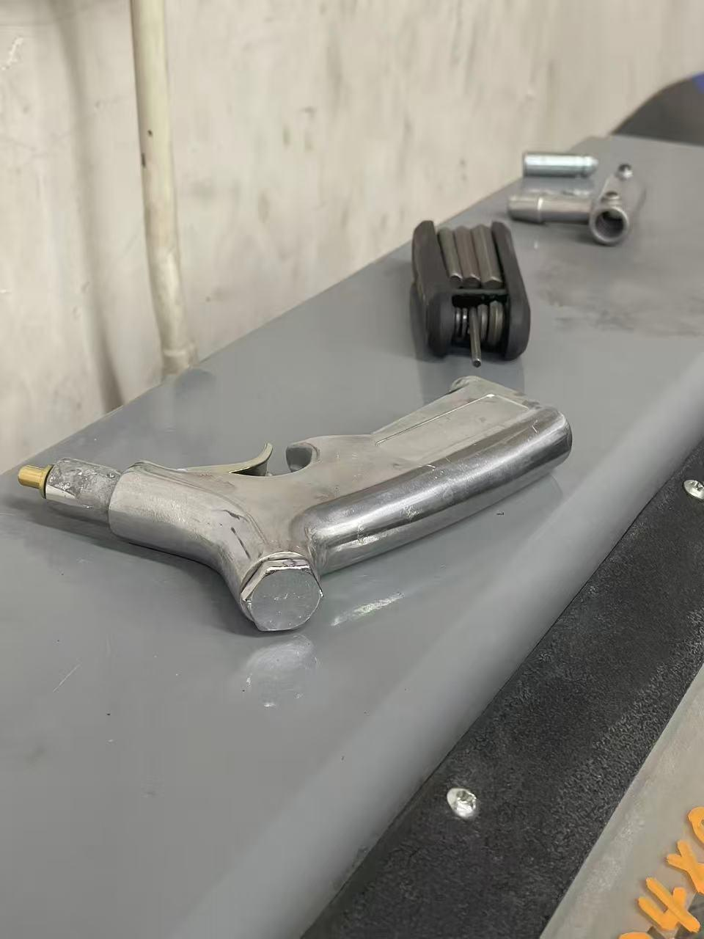
Figure 6. Replaced Sandblaster Nozzle

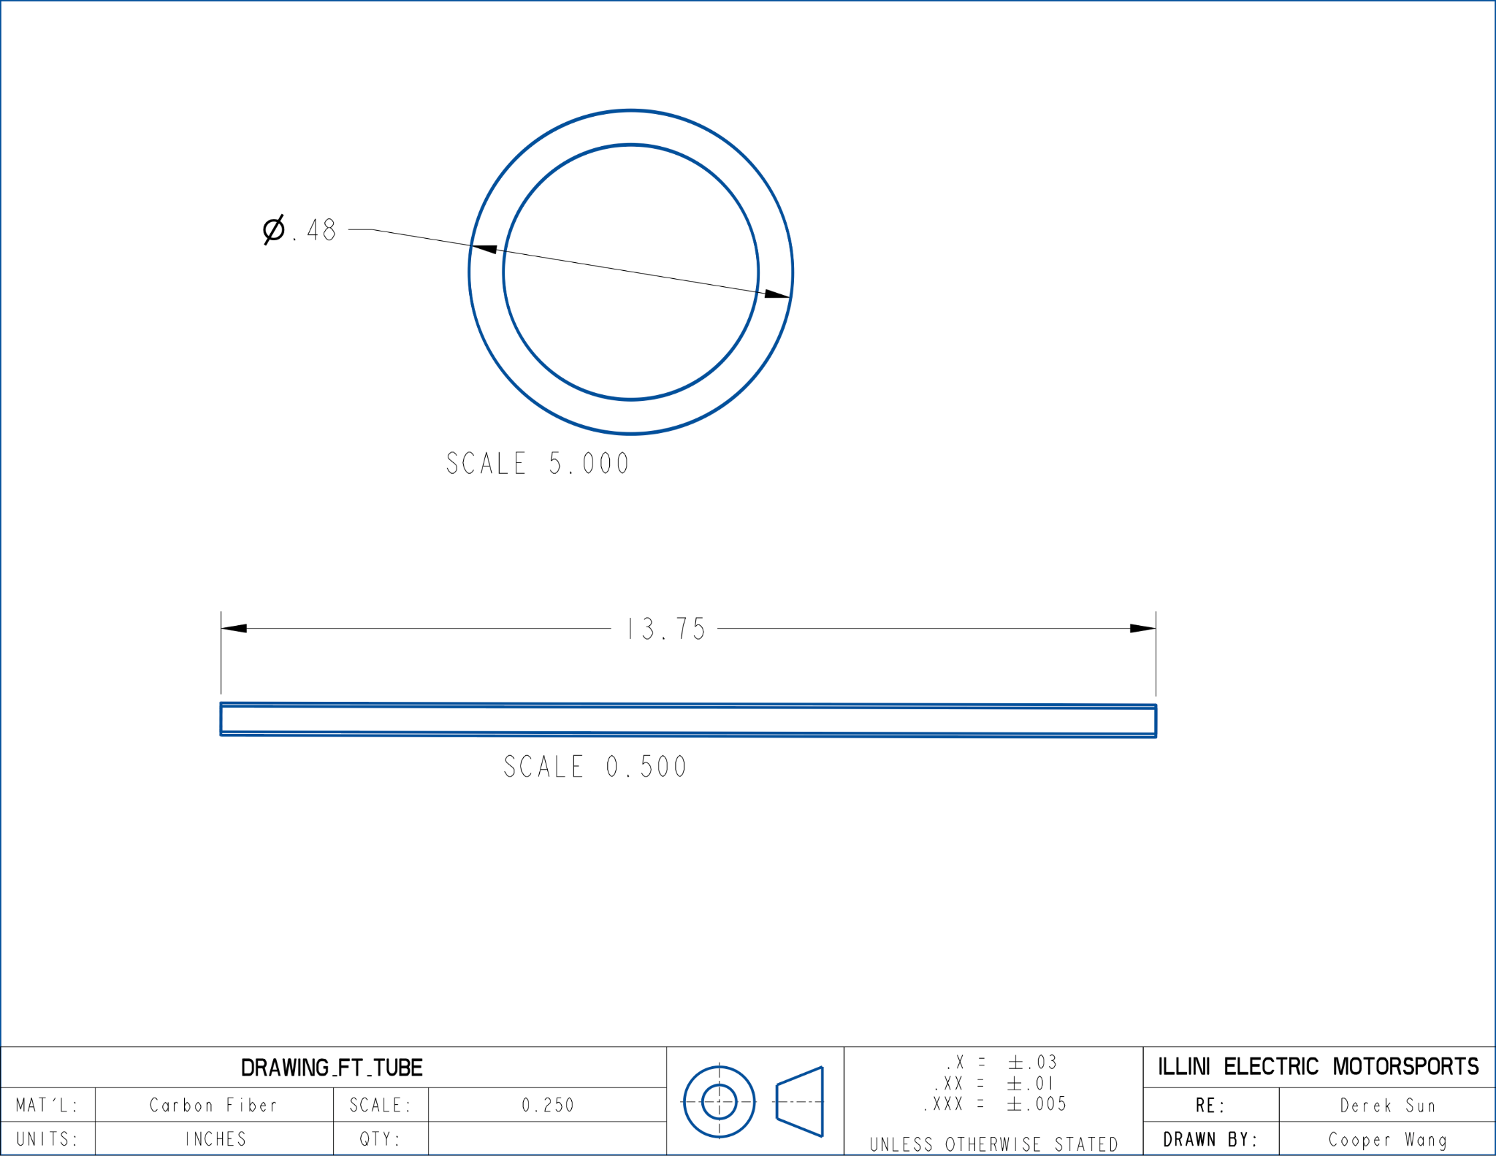
Figure 7. Drawing for the Cost Report
At the same time, I also helped with the assembly of the hubs and various issues that the hubs had. One of the examples is that the bolts for assembling the hubs were too large, and I had to sand the bolt head down manually with sand paper to ensure compliance with the overall assembly.
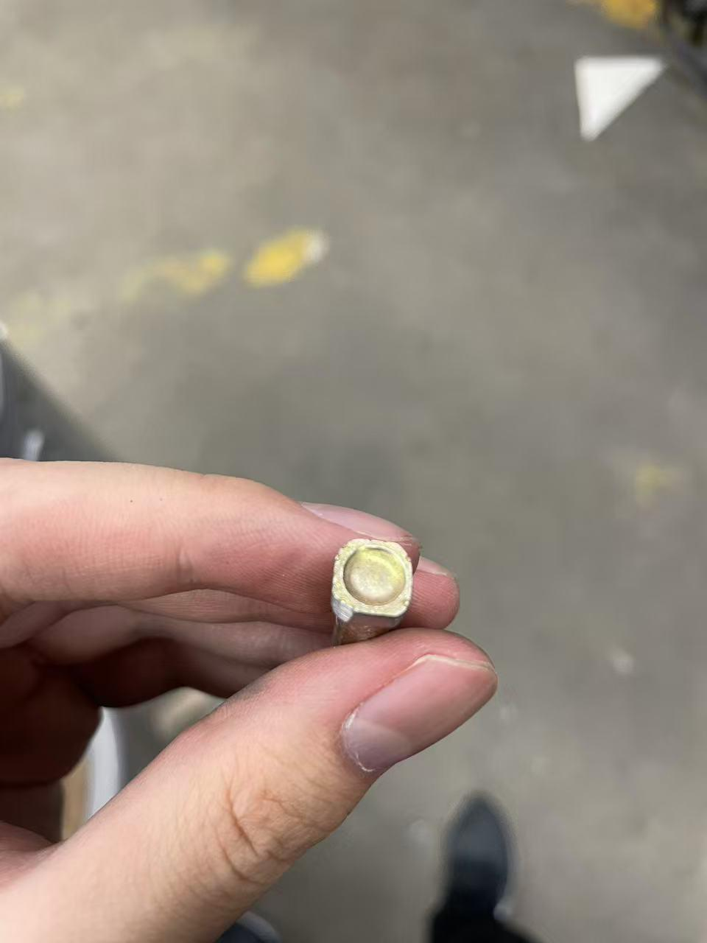
Figure 8. Sanded Bolt Head
Another example is the assembly of the rotorplate, which requires both the spacers and the bolts to align perfectly to work. However, many of the spacers were not concentric, and we had to enlarge the holes by drilling it for the assembly to work. Similarly, the rotorplate also had sizing issues with the spacers, and we had to sand down and deburr the rotorplate as well. At last, since the spacers and the rotorplate needed to be assembled together vertically, we had to work together to make sure that the spacers were aligned and were not falling off the rotorplate when mounting it.
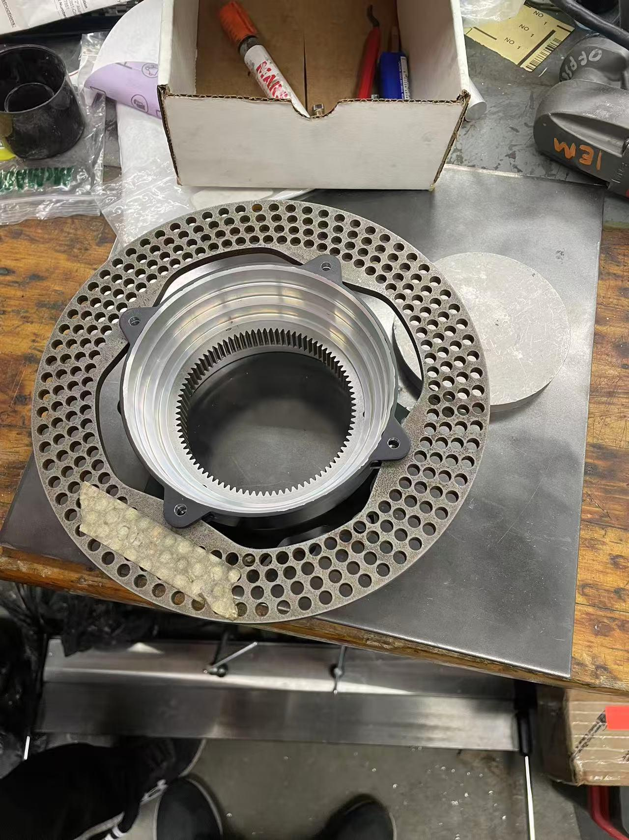
Figure 9. Complete Rotorplate Assembly
Similarly, I also participated in the assembly of the hubs, which also involved complex processes. First, we used Loctite to secure the inner bearing, which was then rotated continuously to avoid the hub getting stuck. I then assembled the gears and put in the lubricant, which is used later for testing. While working on hubs, I also disassembled the A-arms off the chassis for further testing.
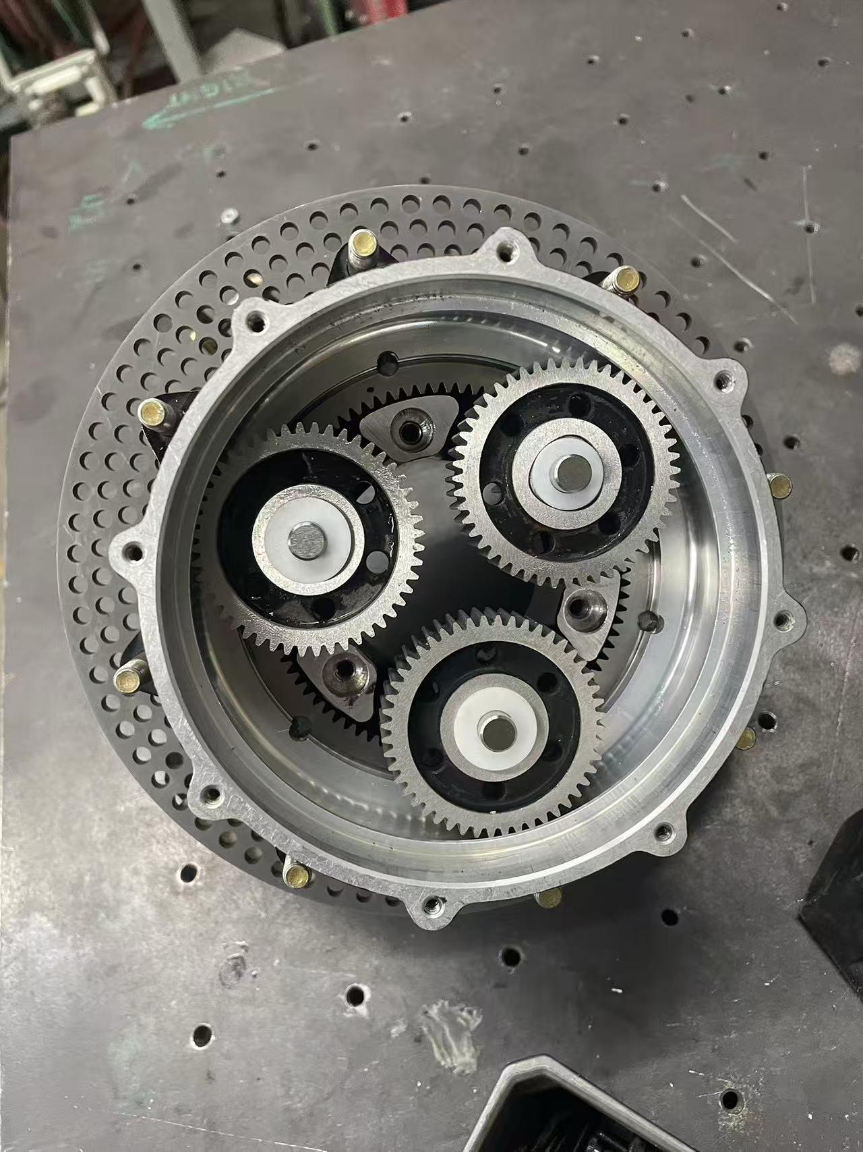
Figure 10. Partial Hub Assembly

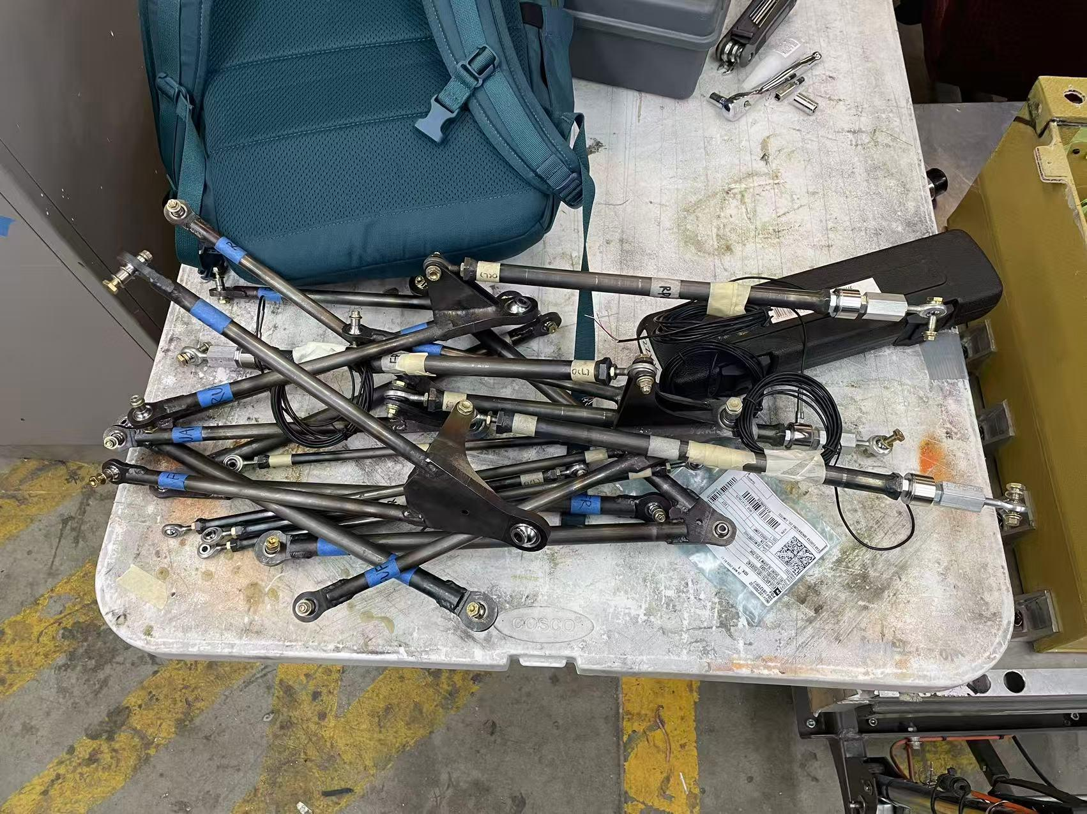
Figure 11. Disassembled A-arms
However, one of the main problems that emerged was that there was constant oil leak from the hubs, which was then discovered to be the result of O-rings being too small and not providing a complete seal. The solution was that we 3D printed rings that would help fill up the spaces in the groove, and put in new O-rings for better seals. However, the process also required the disassembly and reassembly of all the hubs, so I helped to take off all of the hubs off the vehicle again and then reassembled them after the fix was in place.
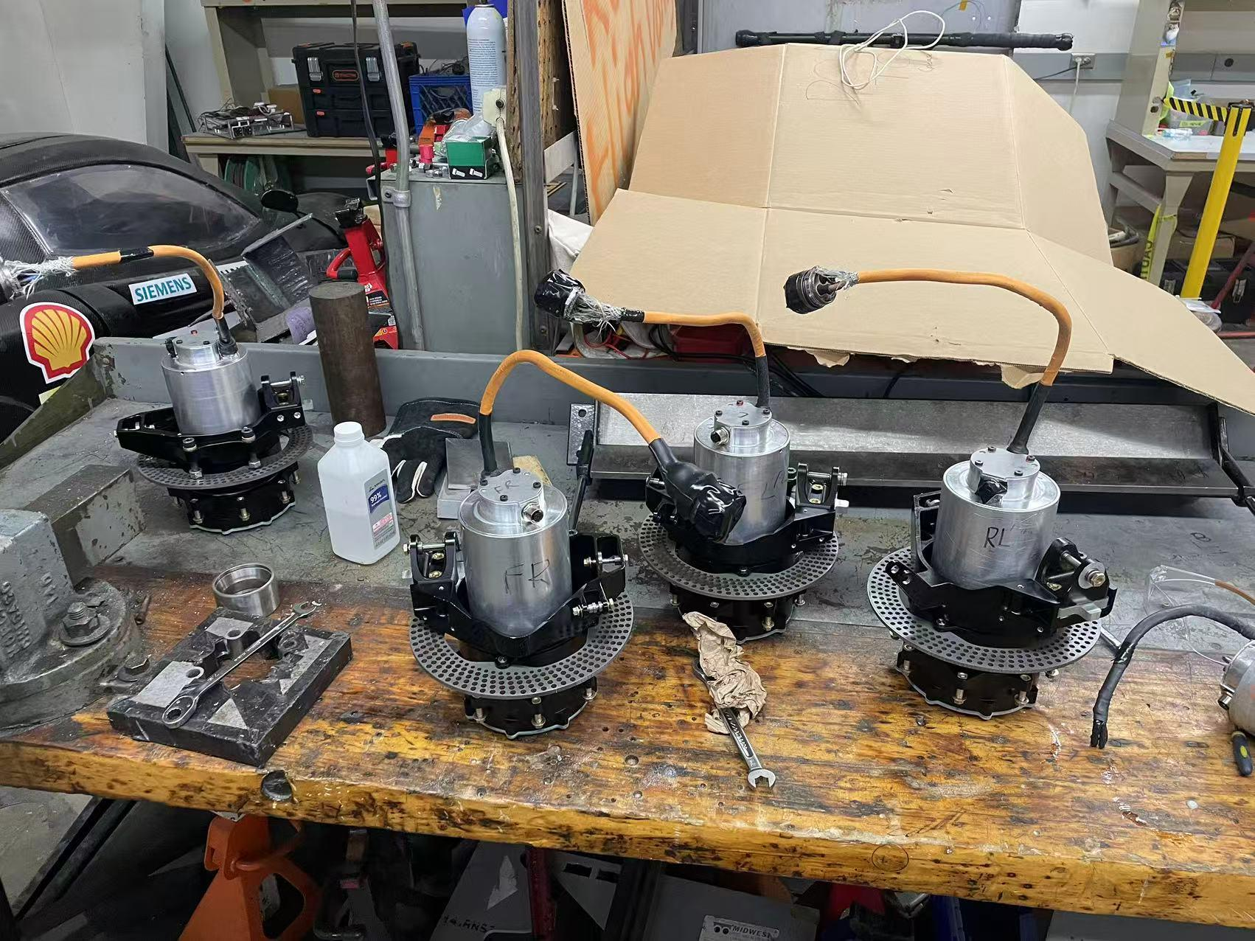
Figure 12. Disassembled Hubs
For the rest of the semester, I will continue to work on helping with the suspension system and the corners to hit our driving car deadline. Some future jobs would include bonding the A-arms with the correct inserts after they arrive, and fixing further hub oil leaks if they take place.

